Lab 3: Identify networking cable standards. Create and test cross-over cables.
Experiment: Do the following cabling works in a network.
a. Cable Crimping
b. Standard Cabling
c. Cross Cabling
d. Testing the crimped cable using tester
e. Share a file between two computers using Ethernet Cable
Objectives:
To do the following:
1. Cable Crimping
2. Standard Cabling
3. Cross Cabling
4. Testing the crimped cable using a cable tester
5. Share a file between two computers using the Ethernet cable
Apparatus/Tools/Equipment/Components:
∙ RJ-45 connector,
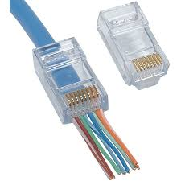

∙ Crimping Tool,
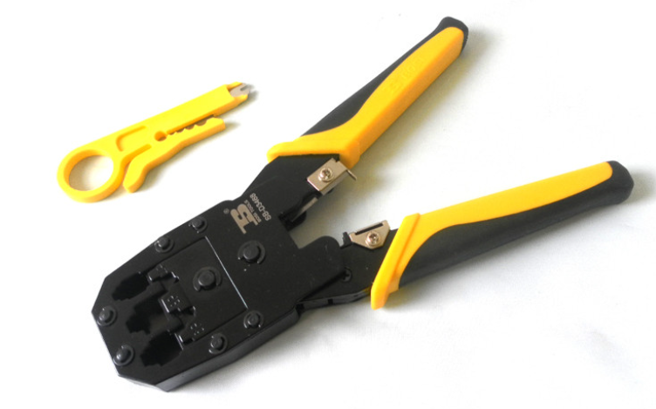

∙ Twisted pair Cable,
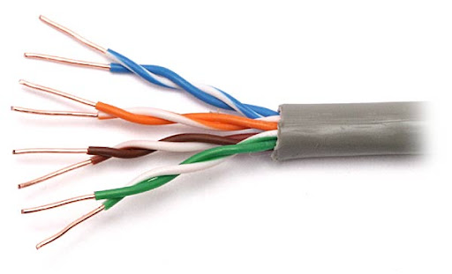
∙ Cable Tester.
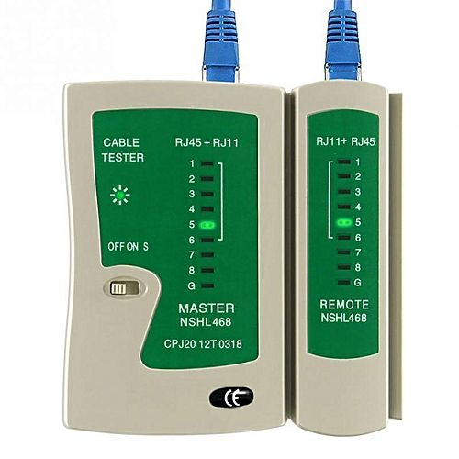
Principle:
Standard Cabling:
- 10BaseT and 100BaseT are widely used types of LAN connections. Both can operate using UTP Category 6 cables.
- To connect a computer with a hub, a straight-through cable is typically used.

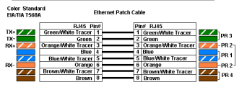Cross Cabling:
A crossover cable is required to directly link two computers using only a UTP cable. It is also used when connecting two hubs via their standard ports..
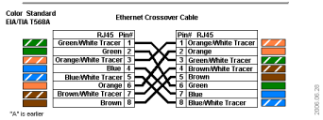Figure 1 Cross Cabling
Procedure:
Cable Crimping steps:
- Peel off 12mm of the outer cover from one end of the cable (this is called side A).
- Line up the metal wires so they are straight and next to each other.
- Do the same steps for the other end of the cable (called side B).
- After both ends are ready, you don’t need to worry about which end goes where.
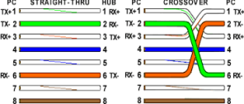
Testing the crimped cable using a cable tester:
- Strip about 3 cm of the outer cable jacket using a cable stripper.
- Untwist each wire pair and straighten each wire to around 1.5 cm in length.
- Trim all the wires so they are even.
- Insert the wires into the RJ45 connector in the correct order, with white-orange on the right and brown on the left, and the pins facing up.
- Put the connector into a crimping tool and press firmly until the handle is fully closed.
- Use a cable tester to check if the connections are working properly.
File sharing using Ethernet cable:
Step 1: Connect two PCs with the Ethernet cable.
1. Right-click the Start button and choose "Control Panel > Network and Sharing Center". You will see the active network or Ethernet.
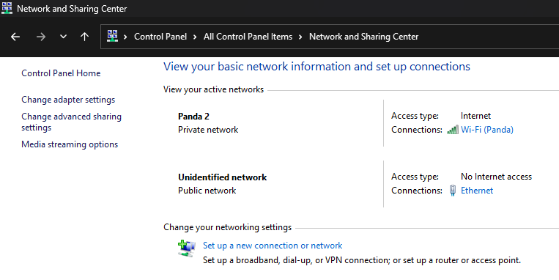

2. Click "Ethernet > Properties > Internet Protocol Version 4 (TCP/IPv4) > Properties".

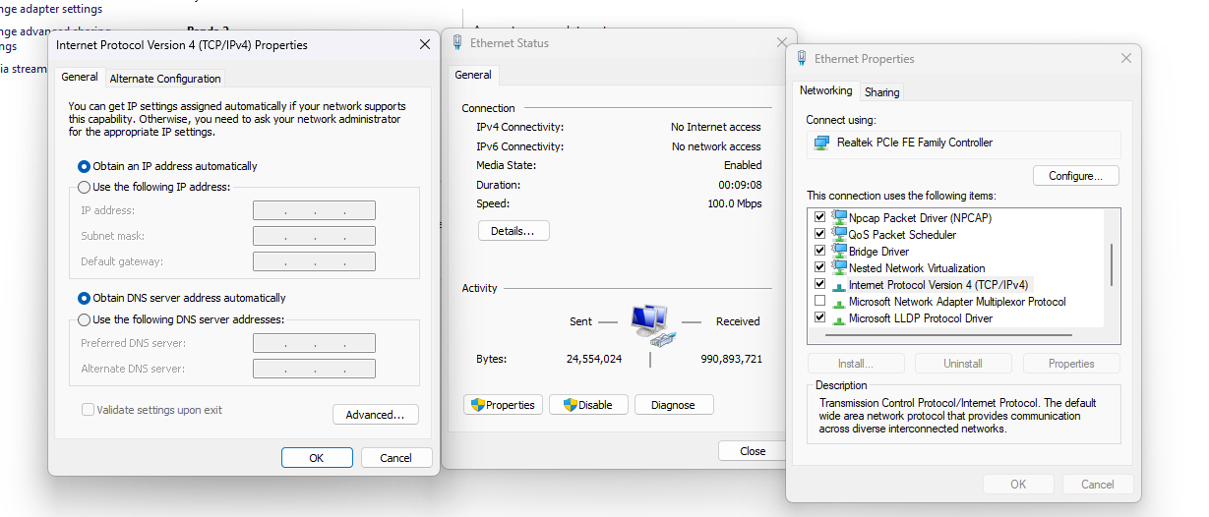

3. Select "Use the following IP address" and type the IP address and subnet mask as
shown in the screenshot below. The IP you enter differs from the example as long as they are in the same range.

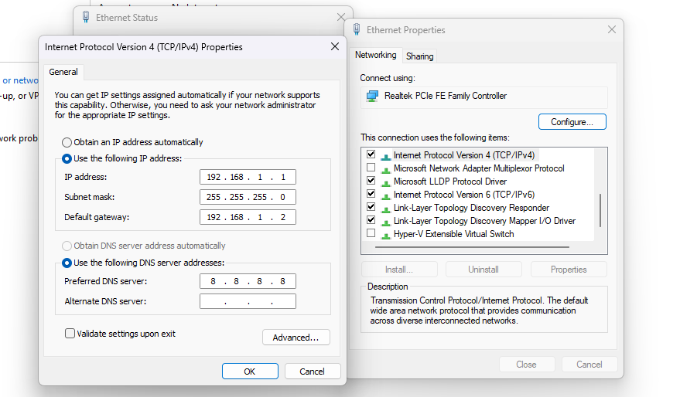
Step 2. Turn on the sharing option on both PCs.
- Go to "Control Panel > Network and Internet > Network and Sharing Center > Change advanced sharing settings".
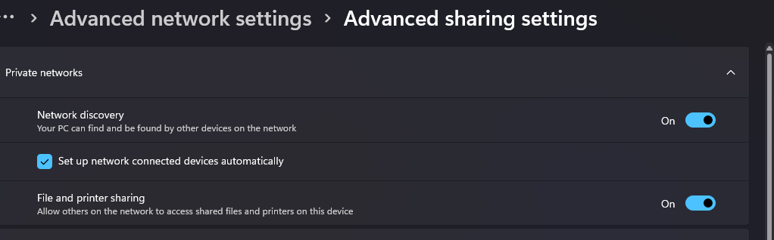
2. Choose these options and click "Save changes".
∙ Turn on network discovery.
∙ Turn on file and printer sharing.
∙ Turn on sharing so anyone with network access can read and write files in the public folders.
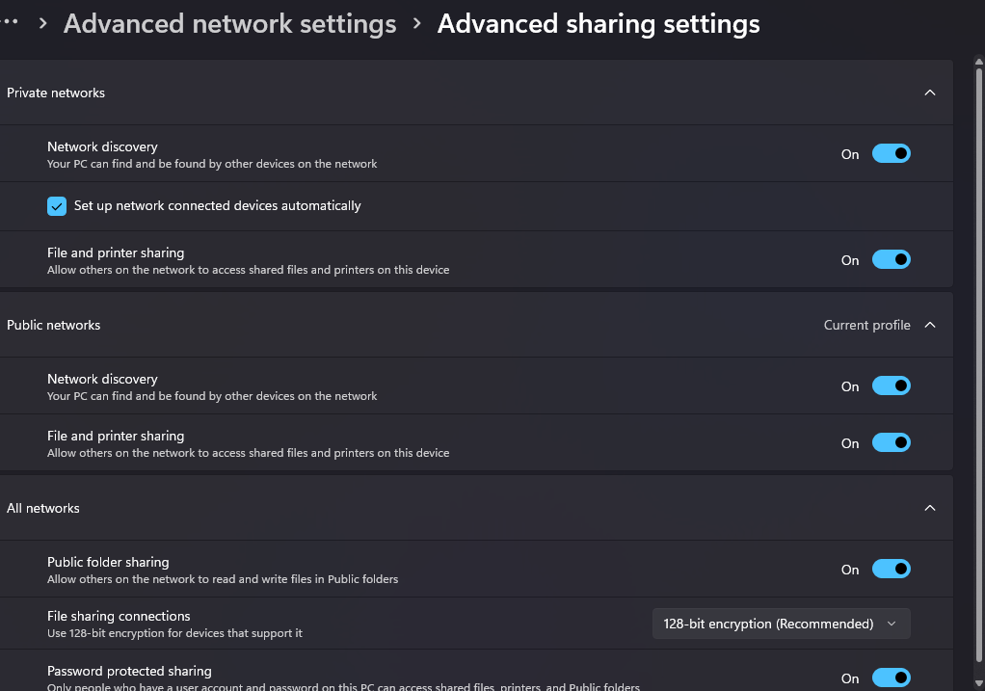

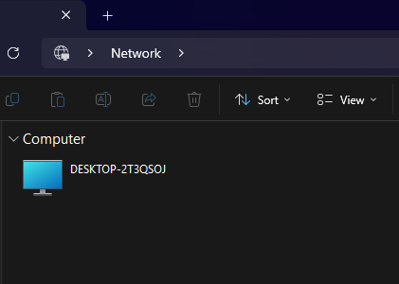

Step 3: Transfer files from one PC to another via Ethernet cable.
1. Select the file or folder you want to transfer, right-click it and click "Share with > specific people".

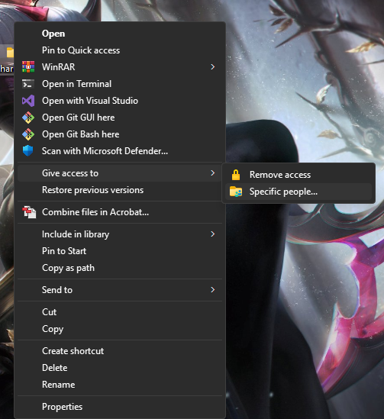

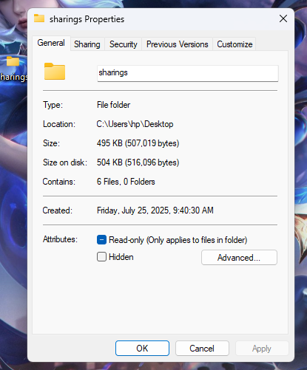
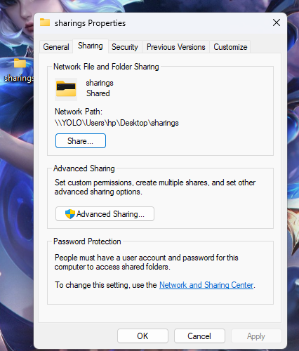

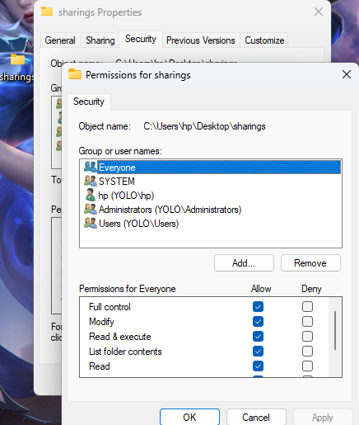

2. On the File Sharing window, click the drop-down menu and select "Everyone > Add > Share". Then, the file will be transferred from one PC to another. You can check the shared files on the target PC.

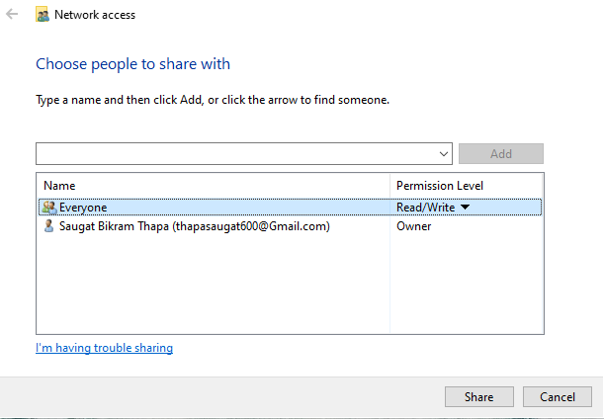

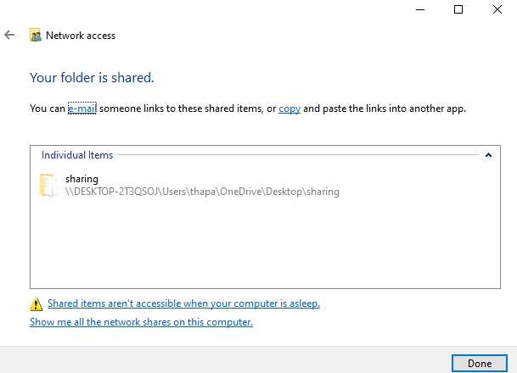

Target PC file:
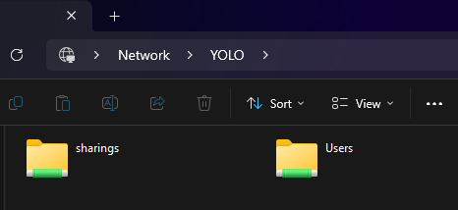

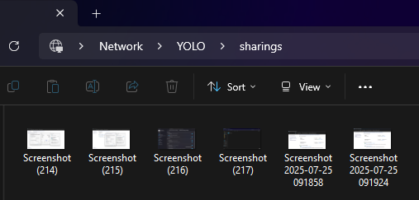
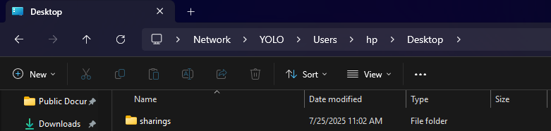
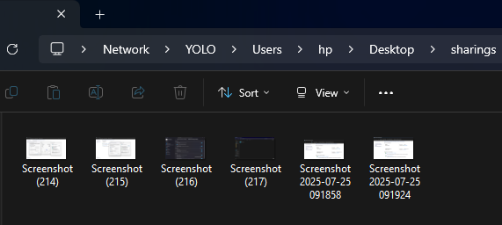

Result:
Cable Crimping, Standard Cabling and Cross Cabling and testing the crimped cable using a cable tester and file sharing between two computers are done successfully.

